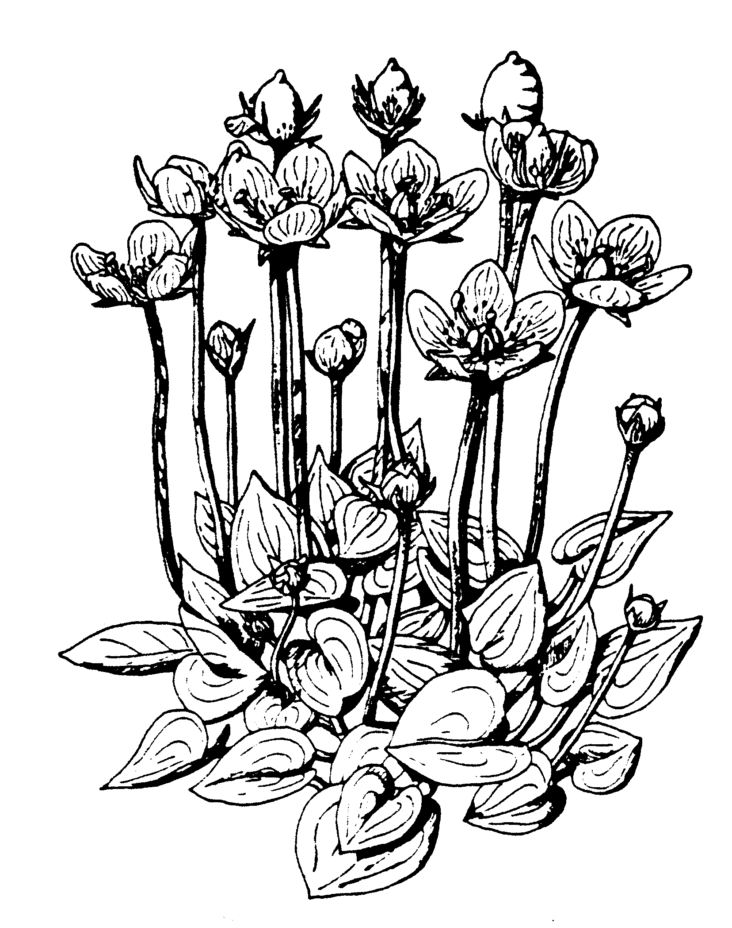The Liverpool Botanical Society
Parnassia: Review of 2016 Field Meetings

For information on the Society please contact Wendy Atkinson at World Museum, Liverpool. Tel: 0151 478 4216
wendy.atkinson@liverpoolmuseums.org.uk www.livbotsoc.weebly.com

Foreword

This is the third shortened format Parnassia account of the previous seasons meetings. Despite his best efforts to keep up to date with the field meetings blog on the website Steven Cross has been thwarted by lack of information reaching him during the season. However, a collective effort is being made to get 2016 information, including species lists, to him to be made available on the website as soon as possible.

As usual our website address, to view the blogs and find out more about the society, is above. Our facebook pages are at: https://www.facebook.com/groups/666270583430427/ . For members who do not have access to a home computer it is very likely that your local library has computers for public use.

Fuller accounts of our field meetings, along with photographs and plant species lists will be available on the website blog pages when available.

Field Meetings 2016

Including joint trips with various other societies (the MNA, WFS and BPS), 18 field meetings were listed in our programme for 2016, these are briefly reviewed below:

Saturday 23rd April: Caergwrle Led by Peter Tipping.
Eighteen of us met for the year’s first outing on a cold but sunny morning. We went along country lanes with species-rich hedges and hedge banks with many plants typical of limestone soils, including the Wayfaring Tree (Viburnum lantana). We followed footpaths through old pastures and wetlands before following the banks of the River Alyn back to Caergwrle. A list of 125 species noted is downloadable from the website, including flowering male and female Marsh Valerian (Valeriana dioica) and Alternate-leaved Golden-saxifrage (Chrysosplenium alternifolium).

Friday 13th May: Altcar Rifle Range This regular evening trip from Hightown Station with Steve Cross.
Over 20 people met up at Hightown Station and Steve led us through the guardhouse procedures and into the ranges, heading west we were soon amongst a record season for flowering Green-winged Orchids (Anacamptis morio), Steve having previously counted 31000 spikes. As well as the range of colour forms of orchid Steve and Phil Smith showed us various other local floral specialities including fine displays of Cowslip (Primula veris), various Creeping Willow hybrids and a stand of Flat Sedge (Blysmus compressus).

Saturday 14th May: Mersey Estuary Bioblitz This event was organised by a variety of interested groups, particularly the Biodiverse Society and took place on 13th and 14th May with Peter Gateley leading a botanical foray on the Friday and Dave Earl leading on the Saturday. A good range of coastal saltmarsh plants was seen as well as the locally distinctive flora of the clay cliffs fronting the Mersey. Of interest also was the sighting of numerous Green Tiger Beetles hunting on the clay cliffs, a different species to the Tiger Beetles found in the dunes.

Thursday 19th May: Lune Valley. Joint trip with the Wildflower Society led by Julie Clarke
On a joint trip with WFS members met at the car park on the former railway line at Halton and Julie led them along the rich banks of the Lune. Some of the notable plants seen included: Dutch Rush (Equisetum hymale), Goldilocks Buttercup (Ranunculus auricomus) and Wood Stitchwort (Stellaria nemorum), along with a nice array of typical woodland plants. The rayed form of Groundsel (Senecio vulgaris var hibernicus) was also found.

Saturday 4th June: Haskayne LNR Leader – Peter Gateley.
Initially a party of 17 set off in fine weather, with two others arriving later. We walked via the canal towpath, and footpaths to the LWT reserve at Downholland Cutting. We were joined at the north end of the reserve by Dr Phil Smith who reported on the count of marsh-orchids there and pointed out a population of the Narrow-leaved Meadowgrass (Poa angustifolia). From there we headed north along footpaths and lanes, finding Purple Ramping-fumitory (Fumaria purpurea) en route.

Saturday 11th June: Cronton Colliery Leader – Dave Earl.
This former coal mine is now a wildlife site with large areas of both planted and naturally regenerated wood and scrub along with wetland, old settling lagoons, grasslands and the course of Fox’s Bank Brook. Dave Earl and Julia Simons led us through these habitats, finding many orchids in flower, including some fine Bee Orchids (Ophrys apifera).

Saturday 18th June: Winsford Joint trip with the Wildflower Society led by Julie Clarke.
15 members met at the old station, Whitegate Way, in fine weather. We headed along an old rail track to a wooded with Silky-leaved Osier (Salix x holosericea), then on to a water body in a small salt subsidence flash. Here we found Round-leaved Wintergreen (Pyrola rotundifolia ssp. rotundifolia), confirmed as a first record for VC58, alongside was also Narrow-fruited Water-cress (Nasturtium microphyllum). Overall 196 species were noted by our leader.

Friday 24th June: Altcar Rifle Range. Leader – Steven Cross
As Fridays are the only time when live ammunition is not used on the ranges this was a good chance to explore the wide range of sand-dune and grassland plantlife that thrives here even when all the Green-winged Orchids have gone to seed.

Saturday 25th June: Cressbrook and Tansley Dales. Leader – Tim Rogers
From Litton village Tim led the group through these Derbyshire dales to enjoy the wide range of species-rich limestone grassland and woodland flora abundant along the footpaths here.

Saturday 2nd July: Childwall Woods.
Peter Tipping and Wendy were able to take over at the last minute as Howard was suddenly very ill and was in hospital, thankfully now recovering. They led the group of 13 members through this urban woodland and into the rich grassland beyond. Marsh orchids (Dactylorhiza spp.) and hybrids were in fine flower and damper areas had Plicate Sweet-grass (Glyceria plicata) and Ragged Robin (Silene flos-cuculi) amongst other typical plants of wetter areas.

Saturday 9th July: Malham. MNA Coach trip. Led by David Bryant.
There is an excellent account on: http://naturalistsnotebook.mnapage.info/2016/07/11/mna-coach-trip-malham-yorkshire-9th-july-2016/

Sunday 16th July: Cwm Idwal, Coach trip, led by John Crowder.
John led a party of 17 through the rain to Llyn Ogwen where Water Lobelia (Lobelia dortmanna), Lesser Skullcap (Scutellaria minor) and Ivy-leaved Bellflower (Whalenbergia hederacea) were all in flower. We then set off in a clock-wise circuit of Llyn Idwal enjoying a wide range of montane species, despite the non-stop rain. Notable were three species of clubmoss: Alpine, (Diphasiastrum alpinum) Stag’s-horn (Lycopodium clavatum) and Lesser (Selaginella selaginoides).

Saturday 23rd July: Ainsdale Leader – Pat Lockwood.
It was a fine day when Pat led 25 of us for our trip up from the Discovery Centre to the green beach, we saw a fantastic range of plants typical of dry dunes, slacks, strandline and brackish wetland areas, many in fine flower. Amongst the highlights were Frog Rush (Juncus ranarius), good numbers of Pyramidal Orchid (Anacamptis pyramidalis), three species of Centaury and Tubular Water-dropwort (Oenanthe fistulosa), the full list of plants seen is available on the website.

Saturday 6th August: Brock Valley Led by Michael Hayward and Alison Evans.
A joint trip with the British Pteridological Society. A group of 14 LBS & BPS members explored the fern habitats along the Brock valley, with handy hints on fern identification characteristics being shared among the group. Some more notable ferns included Borrer’s Scaly Male Fern, (Dryopteris borreri), Narrow Buckler Fern (D. carthusiana), Hard Fern (Blechnum spicant), and a wonderful stand of Great Horsetail, (Equisetum telmateia). On Beacon Fell, later in the day, Mountain Fern (Oreopteris limbosperma) was also seen.

Saturday 20th August: Rainford Leader – Peter Gateley.
Given that we met up in pouring rain 6 members was quite a good turnout! We set off from the station through natural regeneration over former sidings and close to allotments, the grassy glades were quite damp and included a range of alien plants as well as those typical of acidic situations, there was a small dried pond with Thread-leaved Water-crowfoot (Ranunculus trichophyllus). Crossing Rainford by-pass to the birch dominated Siding Lane reserve we enjoyed many ferns. However, the rain was unrelenting so we took a short-cut back to the station.

Saturday 3rd September: Lunt Meadows Leader- Steven Cross.
Despite this being another wet and miserable morning ten of us joined Steve to look around this developing reserve. Although late in season many plants were still flowering, such as Hop Trefoil (Trifolium campestre) and of course many others were in seed. We were able to compare Hairy Tare (Vicia hirsuta) and Smooth Tare (Vicia tetrasperma) in detail and also see both flowers and the broad developing seed pods of Field Pennycress (Thlaspi arvensis).

Saturday 17th September: Malltraeth, Anglesey MNA Coach trip. Led by David Bryant.

Full details on: http://naturalistsnotebook.mnapage.info/2016/09/18/mna-coach-trip-malltraeth-anglesey-17th-september-2016/

Saturday 8th October: Dibbinsdale Leader – Steven Cross
We met up at Bromborough Rake station and crossing the railway into the woodland Steve immediately began to find fungi; between them he and Tony Carter assembled a splendid list of species including minute ones that specialised on living on dead stalks of Stinging Nettle and Bramble. We also enjoyed a wide range of tall herb and woodland plants, many with bright autumn colour such as the crimson and yellow leaves and fluffy white seeds of Rosebay Willowherb (Chamerion angustifolium). Various seedheads also caught our attention, such as the hooked capsules of Enchanter’s Nightshade (Circaea lutetiana) attaching themselves to our clothing.

We look forward to you joining in our range of field meetings in 2017

