Indoor Meetings 2024/25

9 November 2024 | * Grass Identification – Peter Gateley  (online zoom meeting, details to follow)
14 December 2024 | Bryophyte Basics – Gabriel Dixon
11 January 2025 | The Wonderful World of Diatoms – Geraldine Reid
8 February 2025 | AGM  (+ members’ field meeting photos)
8 March 2025 | The ‘Trees & Shrubs Online’ project – Tim Baxter

Indoor meetings start at 11.00am, Weston Discovery Centre, World Museum, Liverpool
(Council meetings start at 10.05am)

Officers 2024:-

Hon. President Steve Cross
Hon. Vice-
President Peter Tipping
Hon. Secretary Wendy Atkinson
Hon. Treasurer Robert Freeth
Hon. Editor Steve Cross
Hon. Librarian Wendy Atkinson

The
Liverpool Botanical Society

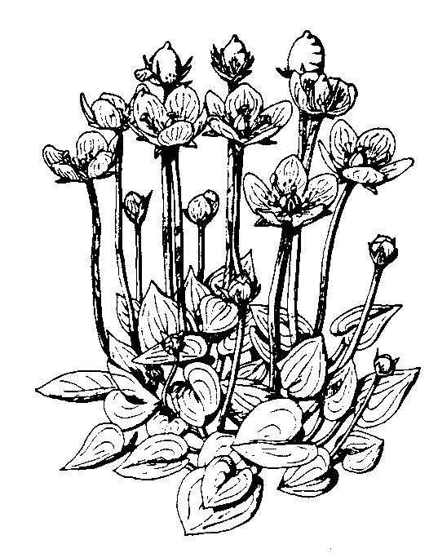2024/25

For information on the Society please
Contact Wendy Atkinson at World Museum, Liverpool
Tel: 0151 478 4216

wendy.atkinson@liverpoolmuseums.org.uk

www.livbotsoc.weebly.com

Attendance at field meetings is at members’ own risk. Please wear suitable footwear, waterproof clothing and bring a packed lunch. For further information on membership application, safety in the field and the latest information, please see our website.

Members will need to pre-book with meeting leaders and give contact details (phone number) so we know who to expect and contact in the event of any last minute changes.

Contact Wendy Atkinson or meeting leaders for further information.

Field Meetings 2024

** indicates joint field meetings with the Merseyside Naturalists’ Association, (MNA) Early booking is advised.

Unless otherwise stated, Field Meetings begin at 10.30

Saturday April 13: Croxteth Country Park
Leader – Steve Cross (07807 341220) Meet at main car park off Muirhead Avenue East, L11 1EH (SJ40483 94156)
(What3Words: object.pass.flight).
Woodland plants.
Saturday April 20: Sankey Valley
Leader - Barbara Allen (07807280088) Meet in the car park outside the Sankey Valley Park visitor centre on Blackbrook Rd. WA11 0AB (SJ534966)
Spring flowers of the Sankey Valley.

Saturday May 18: Tawd Valley, Skelmersdale
Leader – Peter Gateley (07518 685807)
Meet at Skelmersdale Library entrance.
Car parking available at Yeadon Free Car Park WN8 6NL, (SD486061)
Woodland flora of the River Tawd clough.

Saturday June 1: Hightown
Leader – Steve Cross (07807 341220)
Meet at Hightown station L38 3RX. (SD2998203655)
(What3Words: unscathed.enforced.
tasty)
Grassland, dune, and saltmarsh plants.

**Saturday June 22: South Stack, Anglesey
MNA coach trip, Cost £25.
Please book with MNA coach secretary Seema Aggarwal (07984 231059)

Saturday June 29th: Lunt Meadows/Ince Blundell
Leader – Dave Earl (01772 531368)
Meet at Lunt Meadows Nature Reserve car park (SD348023)
(With possible walk to Ince Blundell)
Rubus and other summer flora.

Saturday July 6th: West Kirby dunes, saltmarsh & Red Rocks
Leader – Robert Freeth (07746 745774)
Meet at Dee Lane slipway (SJ210867).
Plants of saltmarsh and sand dunes, including the 'Wirral' Horsetail
(Equisetum x meridionale).

**Saturday July 13: Malham
MNA coach trip, Cost £25.
Please book with MNA coach secretary Seema Aggarwal (07984 231059)

Saturday July 20: Marbury Country Park
Leader – John Crowder (07977 736172)
Meet at Marbury CP car park, Comberbach, Northwich CW9 6AT
Plants of meadow and woodland.
(Please note: there is a carpark charge circa £3.00)

Saturday August 10th: Bidston
Leader – Robert Freeth (07746 745774)
Meet at: Bidston Railway Station (SJ284908)
Plants behind Retail Park & part of abandoned railway sidings.

Saturday August 17: Birkdale
Leader – Steve Cross (07807 341220)
Meet at Birkdale station for 10.30 start (SD330157), and then 11.00 at small car park at Coastal Road/Weld Road roundabout PR8 2PP (SD3206416402)
(What3Words: erase.slime.modest).
Grassland, dune, and saltmarsh plants.

Saturday September 7: Parbold
Leader – Peter Gateley (07518 685807)
Meet at Parbold Station, The Common, WN8 7NU, (SD490107). Car parks at WN8 7DA (over the road), or by the canal bridge to the South.
Late summer canal bank and hedgerow flora.

**Saturday September 14: Leighton Moss
MNA coach trip, Cost £25.
Please book with MNA coach secretary Seema Aggarwal (07984 231059)

Saturday September 21: Marshside
Leader – Steve Cross (07807 341220)
Meet at car park Marshside RSPB
PR9 9TF (SD3522020471)
(What3Words: outfit.factories.tulip).
Saltmarsh plants.

Saturday October 5: Freshfield Fungus Foray
Leader – Steve Cross (07807 341220)
Meet at Freshfield station car park L37 7DD. (SD2912408326)
(What3Words: parent.cats.crass).
Fungi and any late flowering plants.

