Indoor Meetings 2022/23

12 November 2022 | The Scouse Flowerhouse – Richard Scott
10 December 2022 | Picos de Europa – Peter Gateley  (+ Christmas Social)
14 January 2023 | South Lancashire Flora – Dave Earl
11 February 2023 | AGM  (+ members’ field meeting photos)
11 March 2023 | Restoring Southport’s Fernery – Alison Evans

Indoor meeting venue to be confirmed.

Council meetings start at 10.05 and Ordinary meetings start at 11.00am.

Officers 2022

Hon. President Steve Cross
Hon. Vice-President Peter Tipping
Hon. Secretary Wendy Atkinson
Hon. Treasurer Peter Gateley
Hon. Editor Steve Cross
Hon. Librarian Wendy Atkinson

The
Liverpool Botanical Society

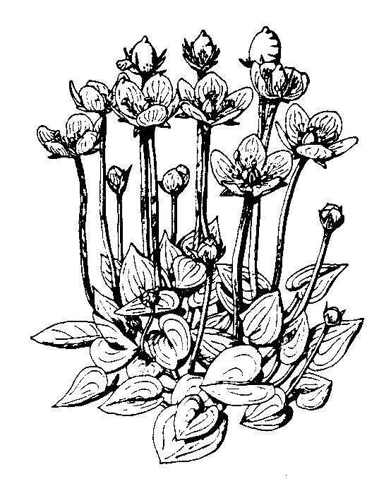
2022/23

For information on the Society please
Contact Wendy Atkinson at World Museum, Liverpool
Tel: 0151 478 4216

wendy.atkinson@liverpoolmuseums.org.uk

www.livbotsoc.weebly.com

Attendance at field meetings is at members’ own risk. Please wear suitable footwear, waterproof clothing and bring a packed lunch. For further information on membership application, and safety in the field please see our website.

Taking part in COVID-safe walks with LBS
Field meetings will be at the discretion of the meeting leaders. Meetings may be cancelled at short notice subject to changes in government advice and/or local lockdown rules.

Members will need to pre-book with leaders and give contact details (phone number) to support NHS contact tracing.

Please be aware of your own risk level and the suitability of this activity in terms of your own vulnerability. Please do not come if you are showing any symptoms of Covid-19, or have recently been in contact with anyone who has contracted the virus.

We recommend that everyone carries alcohol-based hand sanitiser and a face mask.

Please check our website for the latest information: www.https://livbotsoc.weebly.com/

Contact Wendy Atkinson or meeting leaders for further information.

Field Meetings 2022

** indicates joint field meetings with the Merseyside Naturalists’ Association, (MNA)

Unless otherwise stated, Field Meetings begin at 10.30

Saturday April 9: Croxteth Country Park
Leader – David Earl (01772 531368)
Meet at main car park off Muirhead Avenue East, L11 1EH (SJ404941)
Looking out for Selaginella kraussiana and early flowering plants.

Saturday April 23: Sankey Valley
Leader – Peter Gateley (07518 685807)
Meet outside the Sankey Valley Park visitor centre on Blackbrook Road, WA11 0AB. (SJ535966)
Spring flowers of the Sankey Valley.

Saturday May 14: Rivacre Country Park
Leader – John Crowder (07977736172)
Meet at the Ranger/Visitor Centre, Poole Hall Lane, Overpool, Ellesmere Port, CH66 1SS, (SJ3835677760)
Plants of park and woodland.

Saturday June 11: Clock Face Country Park
Leader - Barbara Allen (07807 280088)

Meet in the car park off Gorsey Lane, between Burtonwood and Clock Face, (SJ535915)

**Saturday June 18: Monsal Dale, Derbyshire
MNA coach trip, Cost £20.
Leader – David Bryant
Please book with coach secretary Seema Aggarwal (07984 231059).

Saturday June 25: Minera Quarry, Denbighshire
Leader - Barbara Allen (07807 280088)
Meet in the car park at the end of Maes-y-Ffynnon Road, LL11 3DE (SJ259519). Steep paths, old industrial site with limestone plants.

**Saturday July 2: South Stack, Anglesey
MNA coach trip, Cost £20.
Leader – David Bryant
Please book with coach secretary Seema Aggarwal (07984 231059).

Saturday July 16: Formby dunes to Devil’s Hole and Cabin Hill
Leader – Steve Cross (07807 341220)
Meet at the National Trust Lifeboat Road
Car Park, L37 2EB. (SD275064).
Pay & Display (free for NT members or £7.50 for non-members).
Dune plants.
Saturday August 13: Birkdale
Leader: – Peter Gateley (07518 685807)
Meet at the Esplanade Park and Ride (£2 CP fee for day), PR8 1RR (SD324170),
Shore and strandline plants.

Saturday September 10: Hoylake Beach
Leader - Robert Freeth (07746 745774)
Meet at Lifeboat Station area along North Parade (SJ217897) in CH47.
Plants of new saltmarsh & sea defence walls.

Saturday October 8: Rimrose Valley Fungus Foray
Leader – Steve Cross (07807 341220)
Meet at free car park, Kirkstone Road West, Ford. Next to Our Lady Queen of Peace Roman Catholic Church, (SJ335987).
Fungi and any late flowering plants.

Membership
Annual subscriptions are £5.00
Please see the website for details of online payment.

Alternatively, please send a cheque to:
Liverpool Botanical Society
c/o 6 Prescot Road
Ormskirk
L39 4TQ

