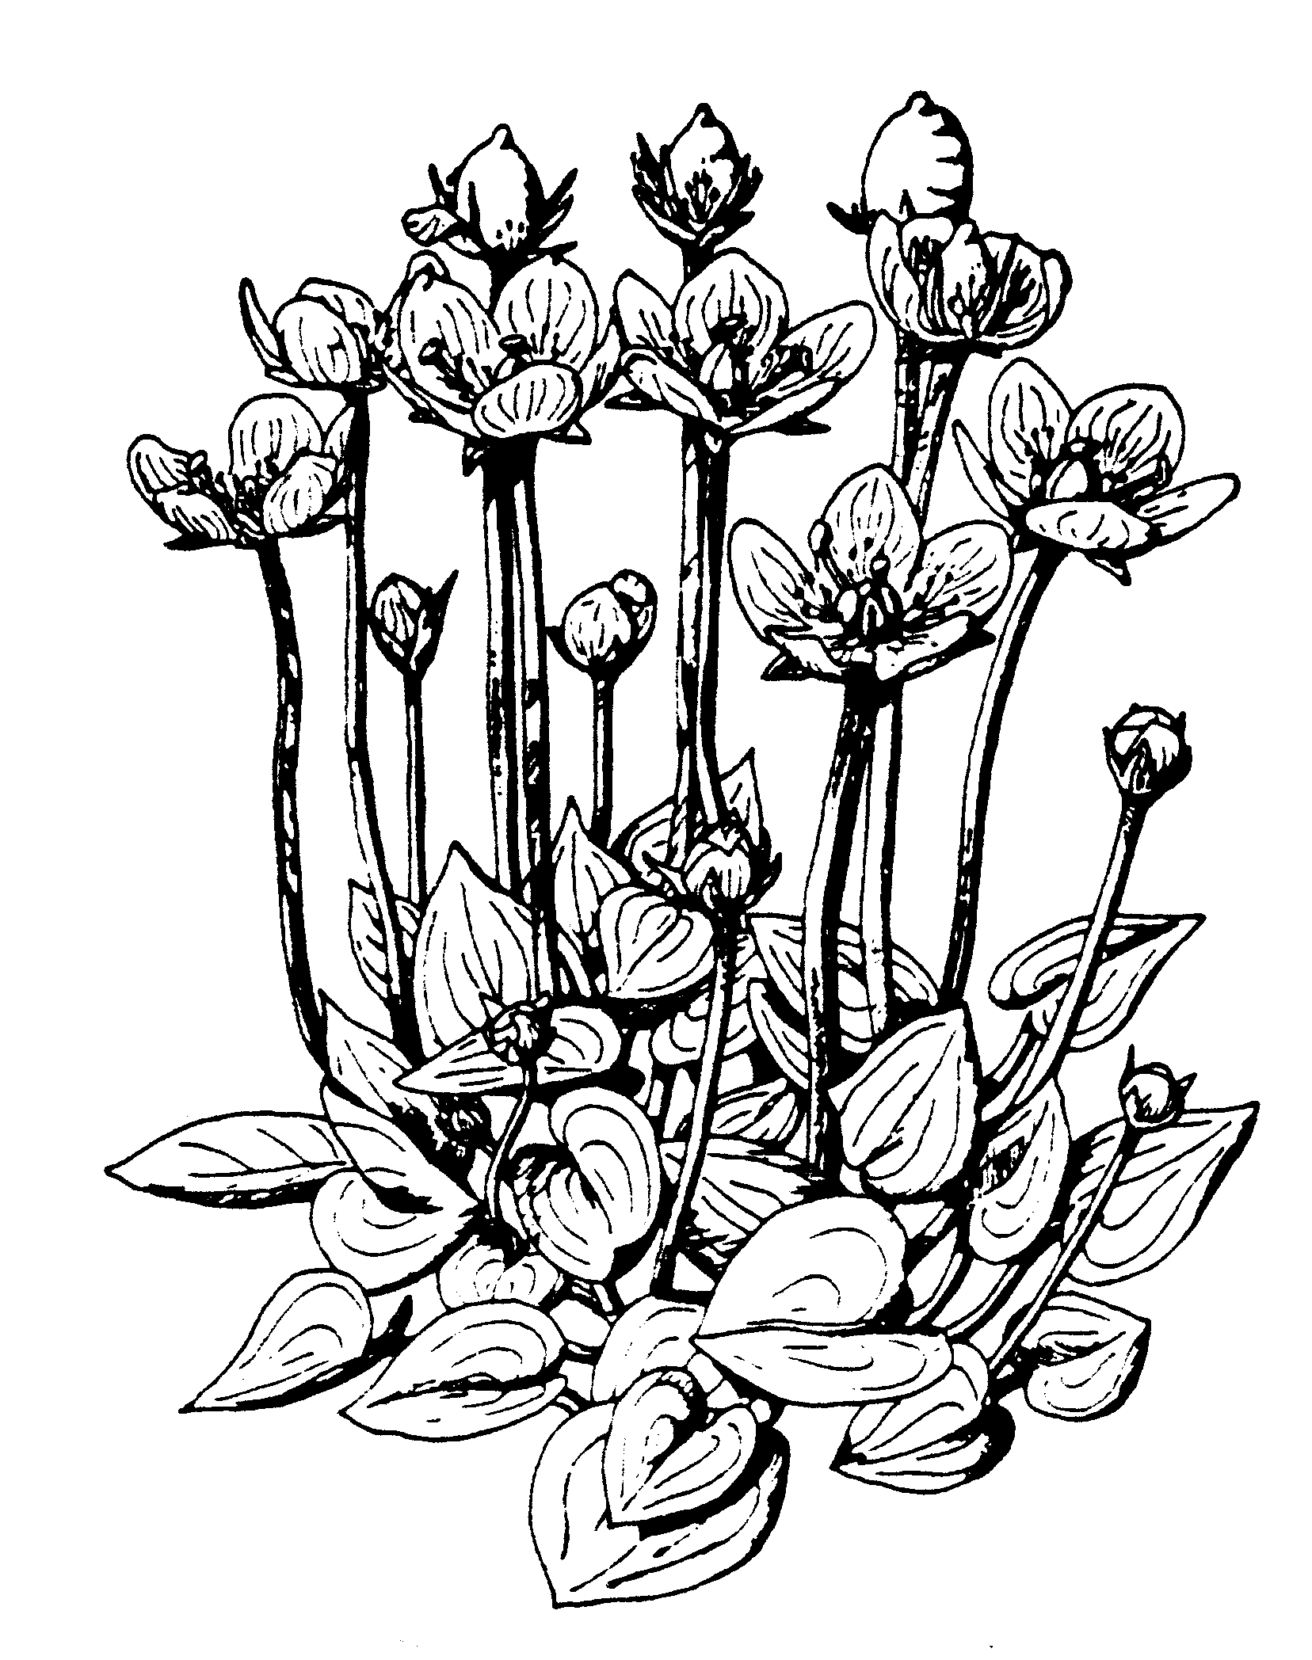The Liverpool Botanical Society
Parnassia: Review of 2014/15 season

For information on the Society please contact Wendy Atkinson at World Museum, Liverpool. Tel: 0151 478 4216
wendy.atkinson@liverpoolmuseums.org.uk www.livbotsoc.weebly.com

Foreword

At the 2014 AGM, two of the items decided on were to make a more concerted effort to record plants observed on our field meetings and also to trim down the onerous task of producing Parnassia in its current form. Steve (Cross) has made herculean efforts producing the expanded version of the newsletter that was launched a couple of decades ago, starting with a backlog caused by the untimely death of Keith Watson, and has brought it up to the present day. However, now that we have the website, blog and facebook sites the effort that goes into preparing, printing and distributing the hard copy does not seem so worthwhile.

The website address is above, our facebook is at: https://www.facebook.com/groups/666270583430427/ . For members who do not have access to a home computer it is very likely that your local library has computers for public use. If the revived short newsletter does not answer your needs then those without computers can request copies of plant species lists and accounts of the visits (when these are available).

So far, plant lists made on field meetings have been submitted to the Merseyside BioBank database (thanks to Ben Deed), rECOrd (Cheshire records) and also VC recorders. For these lists the recorder is usually entered as ‘Liverpool Botanical Society’, rather than individual members names. In the 2015 season all visits should be recorded and records lodged in appropriate databases. Members are also free to submit their own individual records, these must be accurate so don’t hesitate to ask for identification tips on field meetings. Plant names follow New Flora of the British Isles, Stace, 2010.

Field Meetings 2014

Saturday 12th April: Allerton Dave Earl met 21 of us at Liverpool South Parkway station and led us on a most interesting trip through the green spaces of South Liverpool, including Allerton Cemetery and the Eric Hardy Nature Reserve. A good range of urban wildflowers was noted and records submitted to BioBank. Perhaps the most notable was a small group of seedlings of the Monkey Puzzle tree (Araucaria araucana).

Saturday 26th April: Runcorn Woods Just 12 of us turned up to meet Rob Duffy at Runcorn East Station, but we had a bright dry day to meander through a series of woodland and other sites with the timing perfect for wonderful carpets of Bluebell (Hyacinthoides non-scripta). A plant species list was compiled for the tetrads we covered and forwarded to RODIS. En route a welcome stop was lunch at the Norton Priory café.

Fri 16th May :Altcar Rifle Range Another brilliant evening led from Hightown Station by Steve Cross, we were once again blessed by fine weather and enjoyed a superb display of the Green-winged Orchids (Anacamptis morio), along with many other dune, meadow and wetland species.

Saturday 10thMay: Great Orme 20 of us made it to the top of an extremely windy Great Orme to meet our leader Wendy McCarthy, in fact it was so windy the route had to be modified to make it safer! We were shown a magnificent array of plants characteristic of limestone, including national rarities and scarce species, including Spotted Catsear (Hypochaeris maculata) and Wild Cotoneaster (Cotoneaster cambricus). A list of what we saw was sent to the vice-county recorder. In order to see such a wide array of species we had to cover a lot of ground so it was more vigorous than many of our trips and ended with heavy rain joining the strong winds back on top of the Orme.

Saturday 7th June: Gait Barrows Leader – Peter Tipping. Despite the bad weather forecast 10 members assembled, in pouring rain, in the car park where we were subjected to a mighty crack of thunder! However the rain eased and we had an excellent trip listing 147 plant species in this rich limestone reserve. It was great to start with flowering Herb Paris (Paris quadrifolia) but the highlight was the flowering Lady’s Slipper, (Cypripedium calceolus). Even though the rain resumed at lunchtime a good day was had by all!

Saturday 14th June: Brockholes Led by John Ball. A group of us met John at Brockholes Nature reserve on a sunny day to give us a guided tour of the site. We didn’t get far from the car park before we were botanizing around the lake edge surrounding the impressive, floating Visitor Village. Here we spotted water-crowfoot (Ranunculus peltatus), Monkeyflower (Mimulus guttatus) and Gipsywort (Lycopus europaeus) to name but a few. Leaving the Visitor Village, we headed uphill and through meadows where Yorkshire Fog (Holcus lanatus) was in full flower, casting a purple hue over the landscape, and then on to the embankment of the River Ribble, returning via the western edge of the reserve. Other plants included Hairy Sedge (Carex hirta), Tufted Forget-me-not (Myosotis laxa) and the lovely Grass Vetchling (Lathyrus nissolia).

Saturday 21st June: Chorlton-cum-Hardy Leader – David Bishop. A dozen members met up at Ivy Green car park and our very knowledgeable and interesting leader took us into Chorlton Ees and along the Mersey Valley looking at relict water meadow communities as well as other wetlands, hedgerows and dry grasslands. It was a beautiful summer’s day with a range of plants recorded including: Greater Burnet (Sanguisorba officinalis), White Bryony (Bryonia dioica), Wood Stitchwort (Stellaria nemorum) and Flowering Rush (Butomus umbellatus).

Saturday 28th June. Joint M.N.A. and L.B.S coach trip. The journey to Anglesey was awful, driving rain and thick fog. Once parked up at South Stack however the sun came out and factor thirty was needed! The variety of plantlife was as good as it ever is there. Some of the notables were:- Jasione laevis, Sheepsbit, Atriplex laciniata, Frosted Orache but obviously the star of the day was Tephroseris integrifolia ssp. maritima, Spathulate Fleawort or as it is often known South Stack Fleawort. Fulmar, Puffin, and Chough added to a wonderful day as did the Silver Studded Blue butterflies.

Saturday 5th July: Rimrose Valley and Leeds-Liverpool Canal Leader – Steve Cross. It was a lovely warm sunny day for Steve’s trip to this site which he has known very well over a long period. This local knowledge was reflected in over 200 plant species being listed for the days visit by around a dozen members. With the canal along one side and large areas of grassland and developing woodland this site is diversified with wetlands and some relict peat. Greater Spearwort (Ranunculus lingua) and Grass Vetchling (Lathyrus nissolia) were amongst the many plants seen flowering here.

Saturday 12th July: Wigg Island Leader – John Crowder. After meeting at the Wigg Island visitor centre car park John led us around a wide range of habitats between the Manchester Ship Canal and the Mersey estuary with Yellow Bartsia (Parentucellia viscosa) and Broad-leaved Helleborine (Epipactis helleborine) seen in flower. There were good views across the Mersey and some of the effects of the preparation works for the new road crossing could be seen.

Saturday 19th July: Whixall Moss. MNA Coach trip. This turned out to be rather damp visit: however, members of the LBS and the Merseyside Naturalists Association were treated to the botanical joys of a superb example of lowland raised bog habitat, straddling the English/Welsh border. Amongst the typical acidic species seen and enjoyed were Bog Asphodel (Narthecium ossifragum), Cranberry (Vaccinium oxycoccus) and Bog Rosemary (Andromeda polifolia).

9th August: Hightown Leader – Peter Gateley. It turned out to be a glorious sunny day as a group of 24 made their way from Hightown station to the Alt estuary and then headed south along the coast, looking initially at saltmarsh plants and then at the wide variety of dune plants across the wonderful range of Hightown dune habitats. Included in the more than 200 plants recorded (within a single tetrad) were Wild Celery (Apium graveolens), Sea Bindweed (Calystegia soldanella), Common Gromwell (Lithospermum officinale) and Isle of Man Cabbage (Coincya monensis ssp monensis).

30th August: Liverpool Loop Line Leader - Howard Harris. We met up at the National Wildflower Centre car park, Court Hey Park, and Howard led a dozen of us through the park and onto the former railway line, now developed into a long distance footpath and cycle route. The route has well-established scrub/woodland regeneration and linked to various other park and nature reserve sites, over 150 species of plants were recorded including a distinctive stingless nettle, akin to Fen Nettle (Urtica dioica ssp. galeopsifolia) as well as Hoary Ragwort (Senecio erucifolius) and Sweet Violet (Viola odorata).

Saturday 13th September: Maghull Leader - Dave Earl. The group met at Maghull station on another fine summer’s day and headed for the canal which yielded some spectacular exotics: Water Hyacinth (Eichornia crassipes) and Water Lettuce (Pistia stratiotes), also Musk Storksbill (Erodium moschatum) was recorded. Of course, with Dave’s particular expertise, the recorded list of over 130 plants included a good number of Brambles (14 Rubus species) that would otherwise have gone unrecorded, including the ‘Lancashire Bramble’.

Saturday 11th October: Ness Gardens Leaders – Maria Knowles & Tim Baxter. On a dull but dry day Maria met sixteen of us at the garden entrance, introduced us to Tim and we all headed past the house, around which the garden was originally created, to the heather slope. From there we were expertly guided around the staggering tree collection. Maria later provided the annotated list highlighting some of those seen (on website). As well as the trees we were also shown behind the scenes where Tim told the group about Dr Raj Whitlock's long-term experiment on climatic adaptation in grassland plants and about plant propagation processes at Ness. We marvelled at the rate of growth on Vera’s tree.

Indoor Meetings 2014/15

8th November 2014 Working at the Paris Herbarium Wendy Atkinson (+members’ holiday photos)

13th December 2014 Ecological Restoration and Habitat Creation Dr Phil Putwain

10th January 2015 Costa Rica and Other Rainforests Eric & Barbara Greenwood.
January 2015

